Press release

Historical highlights

Illuminated by a Zumtobel lighting solution, the “Museo del Duomo” recounts the history of the famous Cathedral of Milan. Targeted accent lighting is provided by Arcos Xpert LED spotlights that help present the exhibits in their natural beauty, taking visitors to the exhibition on an authentic journey through time.

Dornbirn, January 2014 – Milan Cathedral is one of Europe's most famous churches in terms of architecture. The Museum of the Cathedral is located inside the Palazzo Reale and recounts the cathedral's history –even before the laying of the first stone in 1386 to the present day. With a view to Expo 2015, and in order to make the extensive collection comprising valuable sculptures, paintings, church windows and scale models of the cathedral accessible in their full complexity, the museum had been closed for refurbishment for a few years. November 2013 saw the reopening of the exhibition, which has been allocated more space and is now presented in a new light.

Visitors will embark on an exciting journey through time on a floor space of some 2,200 sqm, divided into 27 large rooms and grouped into 13 thematic areas. By providing a lighting solution that boasts an unobtrusive design language and can be precisely adjusted to any situation, Zumtobel has set the course for allowing visitors an authentic experience and glare-free exploration of the exhibits.
The exhibition centres upon the scale models of Milan Cathedral made from a variety of materials such as plaster, bronze and wood, the largest – and also oldest – among them a walk-in model made of wood, built at a scale of 1:20. The historic model originating from 1519 is made alive by an interplay of light and shadow imitating natural sunlight.
The well-devised lighting concept is based above all on highly efficient Arcos Xpert LED spotlights. As the colour temperature can be selected directly on the spotlight and replaceable optics can be individually adjusted, they provide the versatility and flexibility required by the exhibits' different materials. In order to enhance the sculptures' three-dimensionality and avoid hard shadows, soft outline lenses and accent lighting directed from various positions were used, accompanied by an excellent colour rendering index of Ra 94 as well as UV-free and IR-free LED light that is gentle on the exhibits. Moreover, the luminaires recede into the background thanks to their purist design, yielding the stage to the exhibits.

While the exhibits in the exhibition rooms are mainly illuminated by Arcos Xpert spotlights, highly efficient Panos Infinity LED downlights as well as the Tecton continuous-row lighting system and Linaria light lines are used in the side rooms.
The Veneranda Fabbrica (Venerable Factory) was established more than 600 years ago to supervise the construction of Milan Cathedral. Today, the organisation deals mainly with maintenance, preservation and restoration of the church. One of its well-kept treasures is the Archive situated in the building opposite the cathedral, in Piazza Duomo 20, displaying more than 500,000 historical testimonies and documents dating back as far as to the year 1145. Perluce recessed luminaires ensure gentle illumination of photosensitive documents while at the same time providing ideal lighting conditions for the staff's work.

Thanks to this interplay of flexibility and lighting quality, taking conservational aspects into account as well as ensuring high energy efficiency, the lighting solution could not fail to impress both clients and architects. In the course of intensive design work and based on several models, they managed to jointly develop an individual lighting concept resulting in fascinating brilliance.

About the Museo del Duomo:
The Cathedral of Milan is the principal landmark of the city and one of the most important buildings in the world. From the beginning of its construction, the Veneranda Fabbrica has kept watch over the cathedral and collected valuable historical testimonies. The new museum and the refurbished archive are true treasure troves that not only allow insights into the cathedral's history spanning more than six centuries, but also take visitors to an exciting journey through Milan's past. For a visit to become an authentic experience, architects and designers have relied on visual and haptic design elements to make all dimensions of the Cathedral as well as its fascinating history come alive.

Captures:
(Photo credits: Zumtobel)
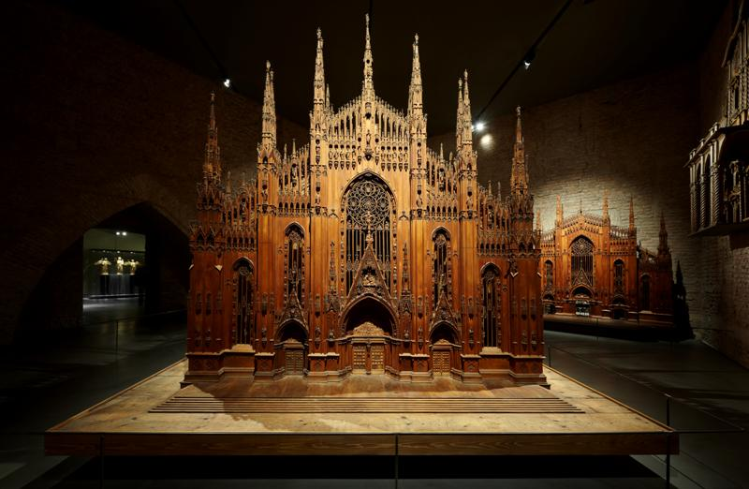
Image 1: The exhibition centres upon the scale models of Milan Cathedral made from a variety of materials such as plaster, bronze and wood, the largest – and also oldest – among them a walk-in model made of wood, built at a scale of 1:20. The historic model originating from 1519 is made alive by an interplay of light and shadow imitating natural sunlight. The well-devised lighting concept is based above all on highly efficient Arcos Xpert LED spotlights.

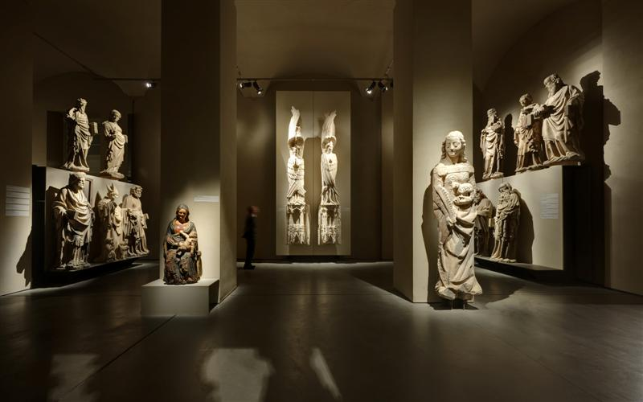
Image 2: In order to enhance the sculptures' three-dimensionality and avoid hard shadows, soft outline lenses and accent lighting directed from various positions were used

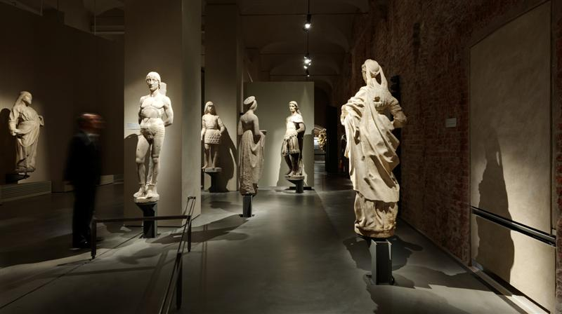

Bild 3: Visitors will embark on an exciting journey through time on a floor space of some 2,200 sqm, divided into 27 large rooms and grouped into 13 thematic areas. By providing a lighting solution that boasts an unobtrusive design language and can be precisely adjusted to any situation, Zumtobel has set the course for allowing visitors an authentic experience and glare-free exploration of the exhibits.

Fact box
Lighting solution: | ARCOS Xpert spotlights in the exhibition rooms  PANOS Infinity downlights in the side rooms  TECTON continuous-row lighting system, LINARIA light lines, PERLUCE recessed luminaires in the archive
Client: | Veneranda Fabbrica del Duomo, Milano
Architects: | CanaliAssociatisrl, Parma
Lighting design: | CanaliAssociatisrl, Parma

For more information, please contact:
Zumtobel Lighting GmbH  Sophie Moser  PR Manager  Schweizer Strasse 30  A-6851 Dornbirn  Tel. +43-5572-390-26527  Mobile +43-664-80892-3074  E-mail sophie.moser@zumtobel.com  www.zumtobel.com | Zumtobel Illuminazione Srl.  Matteo Pallaver  Marketing Communication  Via Isarco 1  I-39040 Varna  Tel. +39 0472 273 31  Fax +39 0472 273 325  E-mail matteo.pallaver@zumtobel.com  www.zumtobel.it

About Zumtobel
Zumtobel, a leading international supplier of integral lighting solutions, enables people to experience the interplay of light and architecture. As a leader in innovation, Zumtobel provides a comprehensive range of high-quality luminaires and lighting management systems for professional interior lighting in the areas of offices, education, presentation & retail, hotel & wellness, health, art & culture as well as industry. Zumtobel is a brand of Zumtobel AG with its head office in Dornbirn, Vorarlberg (Austria).
Zumtobel. The Light.

